MAST492 Midterm Exam
October 18, 2021

NAME__________________

Answer the following questions with the knowledge you’ve learned from the class lectures, textbooks, and the case studies students have presented. This exam must represent your own individual effort.
The objective of the exam is to demonstrate your ability to think critically and holistically about a contemporary marine environmental issue, and most importantly, to evolve your understanding from what has been done in the past to ever-changing situations. There is no word limit to each answer, but we recommend you use succinct sentences (or bullet points if needed) to address those questions, which are crucial for efficient communication.
Please submit a word/PDF file to Canvas by 5:00 pm Wednesday, October 20, 2021 (recommended).
- (20%) Figure 1 shows you the seasonally varying riverflow at the Conowingo Dam in the lower Susquehanna River, along with a water quality parameter X at a long-term monitoring station in the upper Chesapeake Bay (1988-2019 climatology, Data from Chesapeake Bay Program Datahub). What water quality parameter do you think X represents, temperature (unit: ºC), salinity (unit: psu), nitrogen (unit: mg/L), chlorophyll (unit: mg/L), or total suspended sediments (mg/L)? Provide at least three convincing arguments to justify your answer (Hint: the absolute value, range of variation, and seasonal phasing with riverflow).
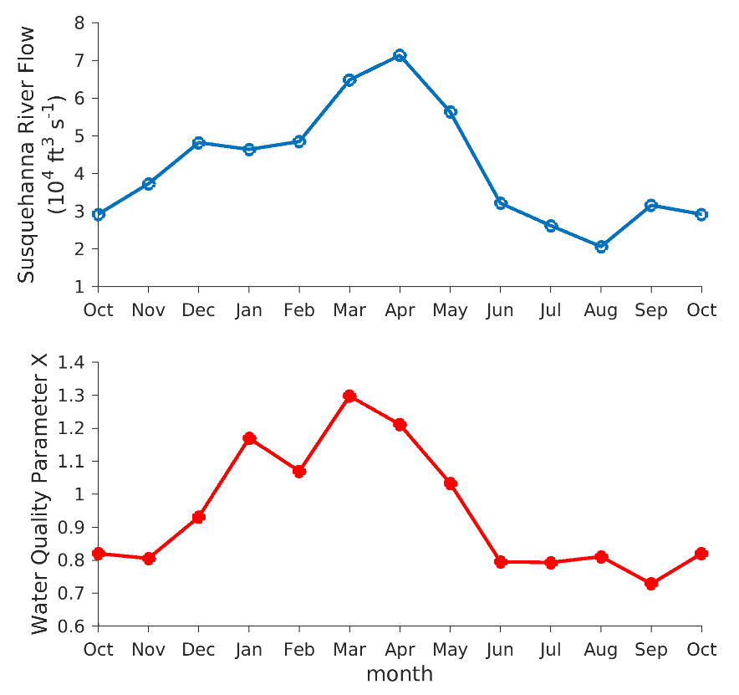

The water quality parameter is salinity. Salinity is a measure of the content of dissolved salts in the water or soil. Salt is highly soluble in water and can be transported with water movement in the river flow. Salinity is measured using practical salinity scale and the units are practical salinity units. Below are reasons for the answer:
- The absolute value of the salinity parameter is 1.3 practical salinity units (psu). Absolute salinity in many occasions provide accurate and consistent representation of any system. It is more accurate and precise hence used to estimate salinity in water systems ranging within various depths and temperature.
- In terms of range of variations, there is low salt concentrations at high flow as clearly seen in the months of November, February and September. High salt concentrations are observed at low flow as seen in the months of December, January, March and October.
- Different seasons in the region affect the salinity levels of the river throughout the year. Seasonal phasing affects velocity,

- (20%) What natural factors and human activities predominantly affect the seasonal variations in X concentration at the site? Elaborate your answer.
The natural factors affecting the seasonal variations include physical processes like evaporation, freezing and precipitation. In places of low flow, evaporation may take place and this would lead to significant increase in the salinity levels. The human activities that lead to increase in salinity in the rivers include agricultural activities. The chemicals used in pest control and fertilizers and much rich with nutrients that can result into significant increase in salinity. In addition, the industrial activities and urban development all lead to increased salt levels. However, climatic changes contribute to approximately 12 percent in the elevation of salinity levels in rivers and lakes.
- Figure 2 shows you the long-term loading of X into the Bay from the Susquehanna River watershed, along with different sources that can affect X input into the Bay (Data from Chesapeake Bay Program Office).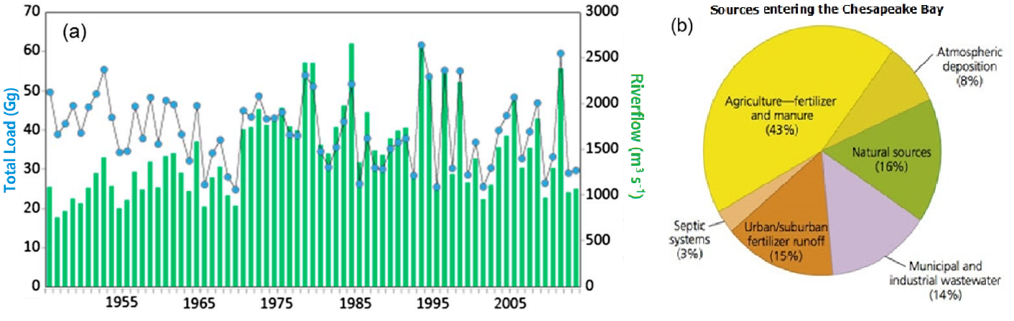
- (20%) What long-term changes in X load do you observe in Figure 2a (e.g., an abrupt increase, interannual variations, etc.)? What types of human activity are likely to cause these changes?
The long-terms changes in the X load can be described as sudden increase with minimal variations all over the years. The type of human activities that might have contributed to this issue include urbanization, the use of fertilizer in agricultural practices. The agricultural practices have a significant contribution of at least 43% in the increase in salinity levels as compared to the other factors.

b. (20%) Based on the pie chart in Figure 2b, what management approaches would likely yield the largest benefits for reducing X inputs into the Chesapeake Bay?
The management approaches that would likely yield the largets benefits for reducing X inputs into the Chesapeake Bay include;
- Planting, regenarating and maintaing natuve vegitation and good groud cover in recharge and discharge zones as possible.
- Encouraging preventative actions to stop salt from moving on the groud and flowing to the rivers. For example, proper maanagement of sewage, from domestic and indutrial activities.
- Adopting cropping practices that reduce deep drainage.
- Siting houses and septic systems away from areas with high water tables.
- Edducating people on the effect of pumbing the industrial wastes and domestic wastes on river sources.
- Rducing agricultural practice near river and lakes. The farmers can use natural was of improving soil fertility like crop ratation and minimize the use of fertilizers.

- (20%) Do you observe any human activity changes in your household during the COVID-19 pandemic in comparison to the pre-pandemic routines? With the stay-in-home order in place for a certain time period, if you scale up these changes of human activity from the household level to the community level in the watershed region, what influences do you expect on water quality parameter X?
(Hint: Figure 3 shows you the water quality parameter X in the period of 10/2019-10/2020 in comparison to its long-term mean seasonal cycle. Data from Chesapeake Bay Program Datahub at the same station as Q1).
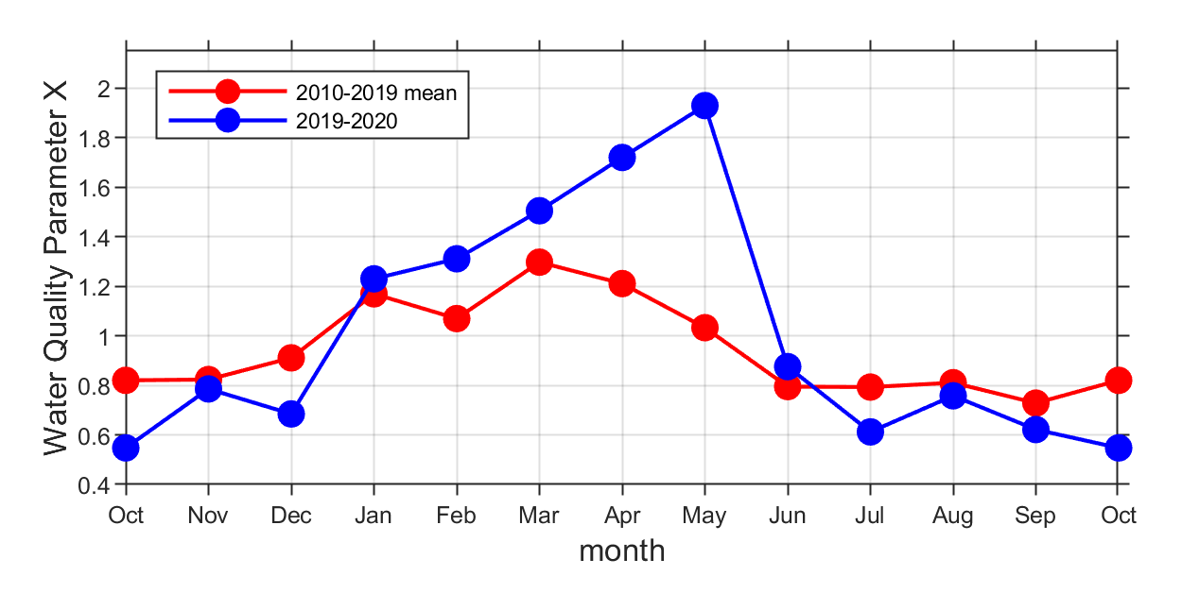
The comparison of statistics on changes in parameter X show that it increased significantly during the COVID-19 period due to the stay-at home rules. The household activities in led to increased salinity in the rivers following the increased use of substances that increase the salt content. It is surprising that the households have poor septic systems that allows the domestic wasted to flow in water sources. The more people used the domestic resources for daily activities, the higher the pollution and thus increased salinity.
- (Bonus, 25%) We have learned a handful of water quality parameters in the class. Besides the water quality parameter X, can you predict what other water quality parameter(s) may deviate from its seasonal/climatological norms in a near term (e.g., <1 year) due to the human activity changes during the COVID-19 pandemic? Provide at least one justification for your prediction.

The other factors that may be affect the quality of water based on seasonal or climatological changes include;
- pH
- Nutrients
- Dissolved oxygen
The reason for the changes in Ph, nutrients and dissolved oxygen over COVID-1 pandemic is due to increased flow of domestic wastes on the rivers and lakes. The pH is affected due to changes in carbon (IV) oxide concentration. In addition, water nutrients are affected by chemicals like phosphates and sulfates from the domestic wastes. For example, the soaps and detergent used for cleaning ends up in the water sources and thus affecting water quality. The amount of dissolved oxygen in water also varies due to changes in the chemical concentration levels.

